1)Ping command

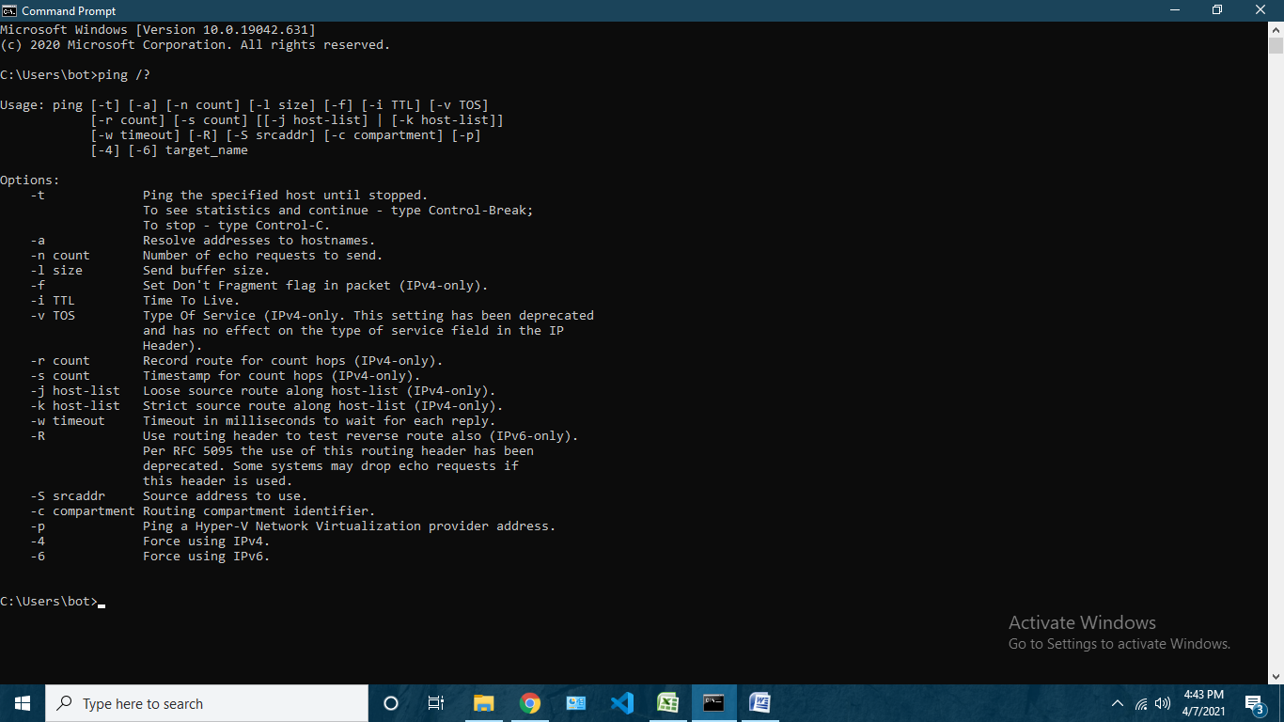

1. Option ‘–t’ is used to ping the host until stopped 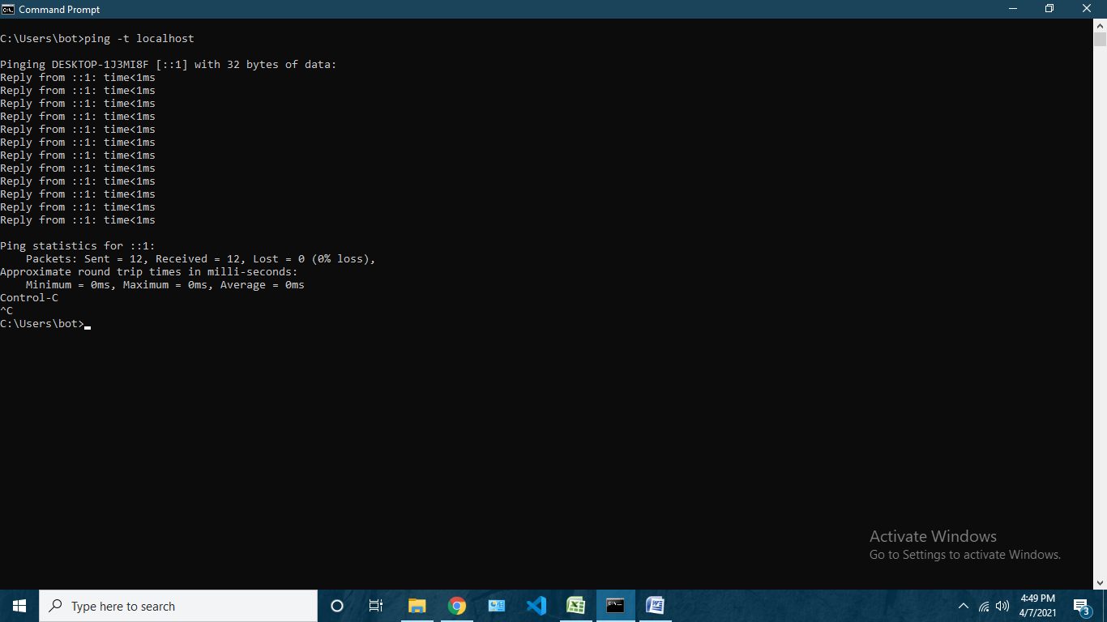
2. Option ‘–n count‘ is used to specify number of echo requests to be sent 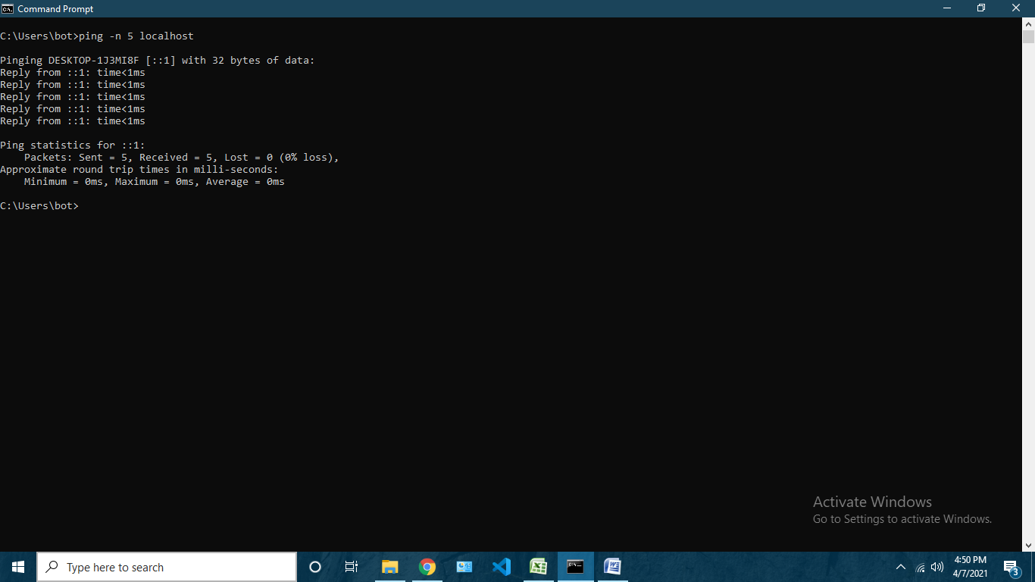
3. Option ‘–l’ is used to specify ping buffer size 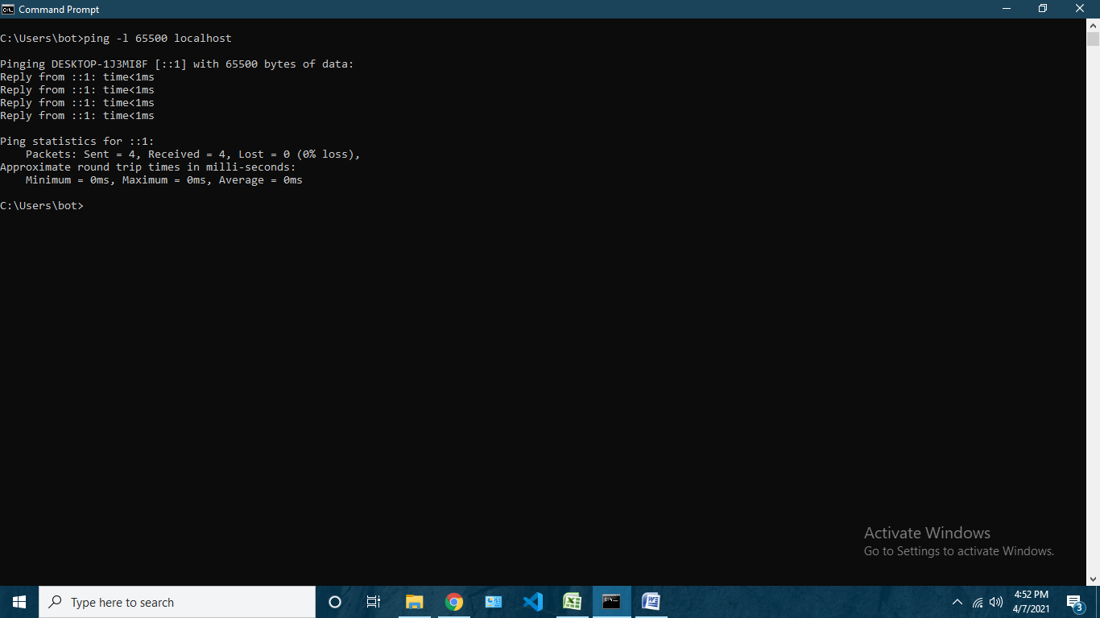
4. Option ‘–i’ is used to specify TTL of packet 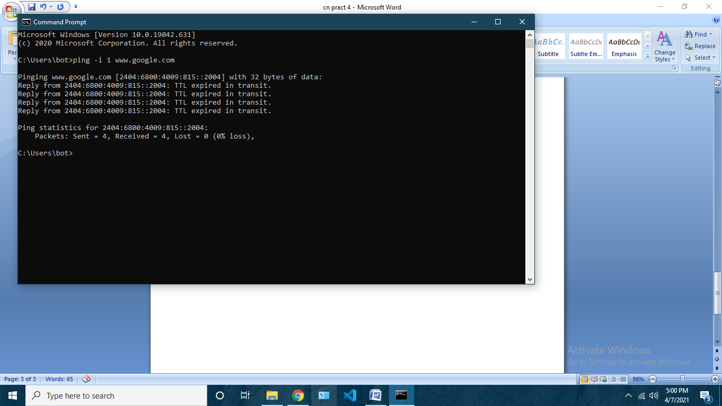
5. Option ‘–6’ is used to ping the host using ipv6 address 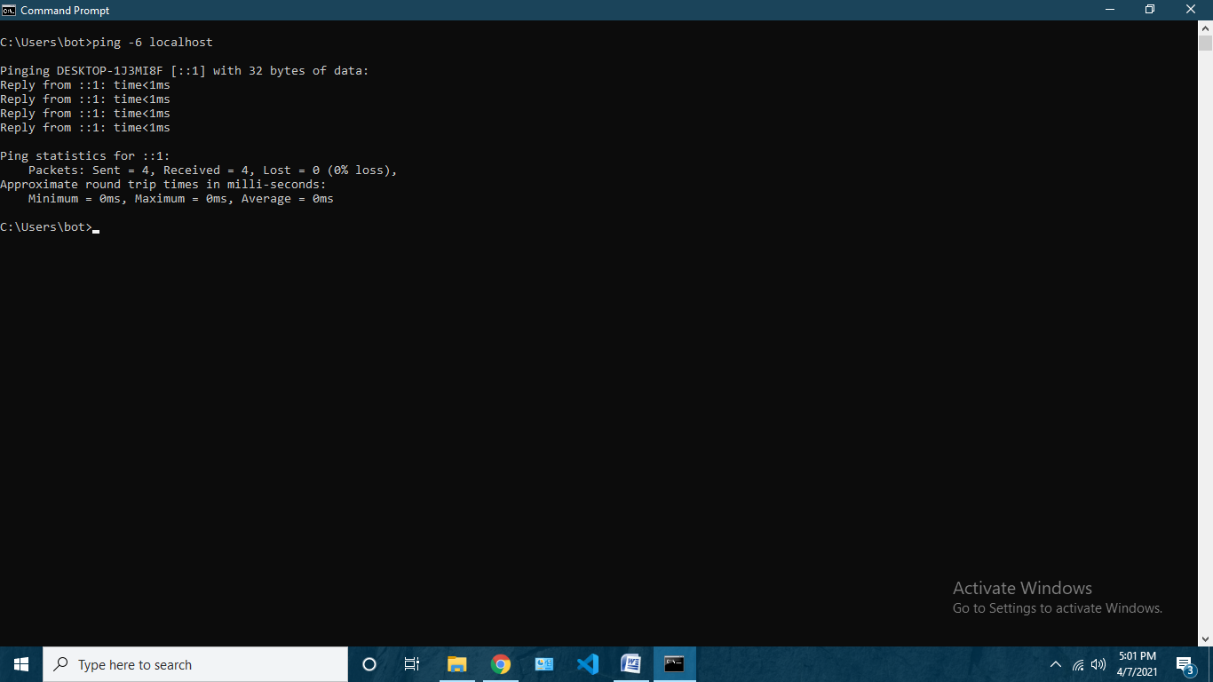

2)tracert

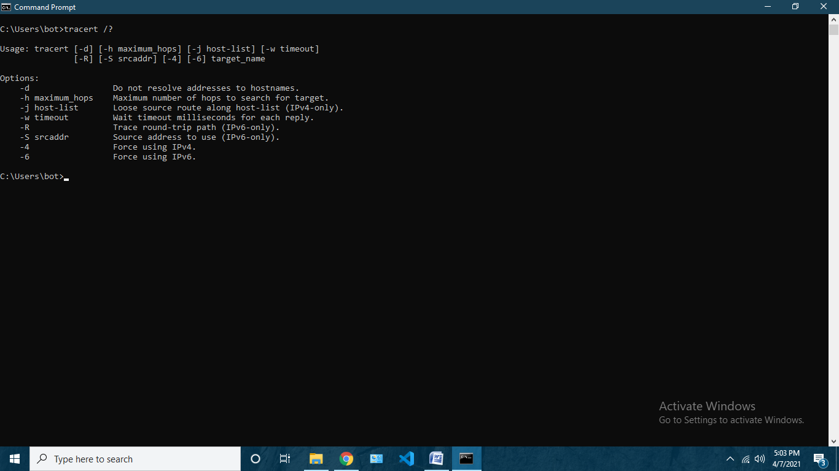

1. ‘option –h maximum_hops’ is used to search for maximum hops to search for target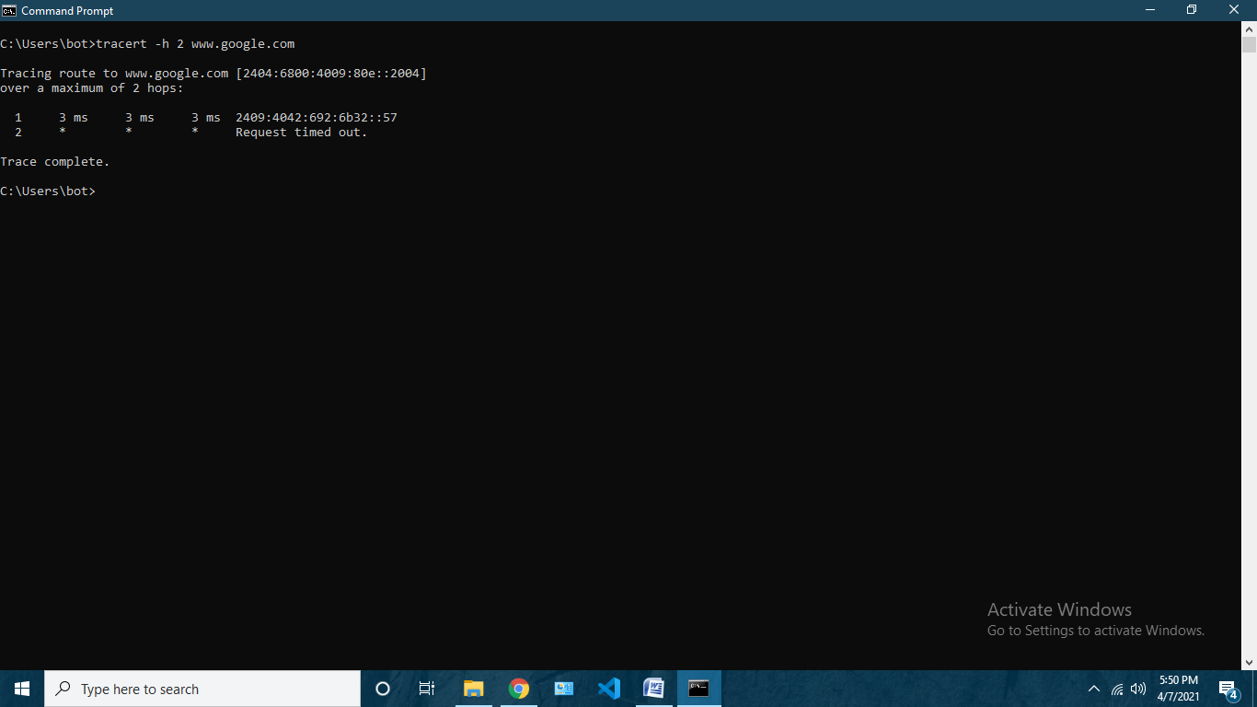
2. ‘option –w timeout’ is used to specify wait timeout in milliseconds for each reply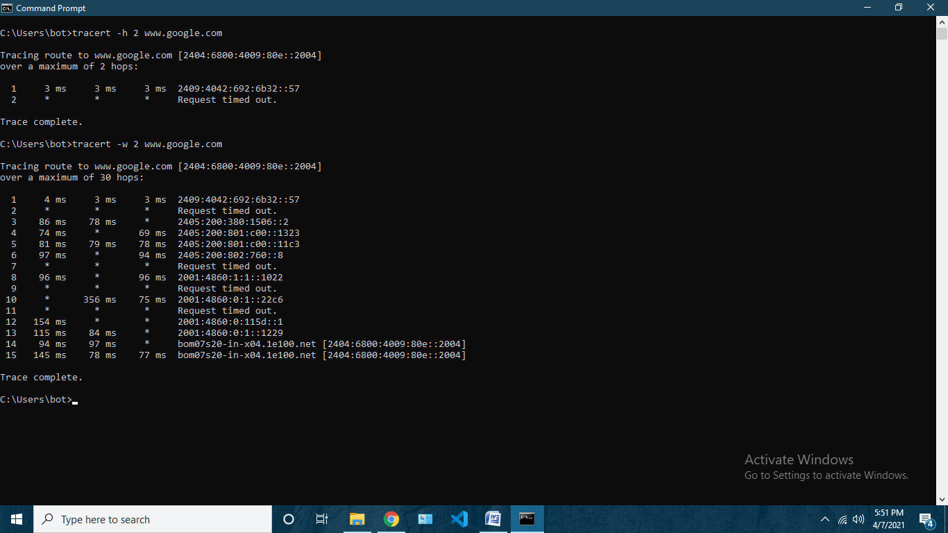
3. ‘option –R’ is used to echo ROUND TRIP PATH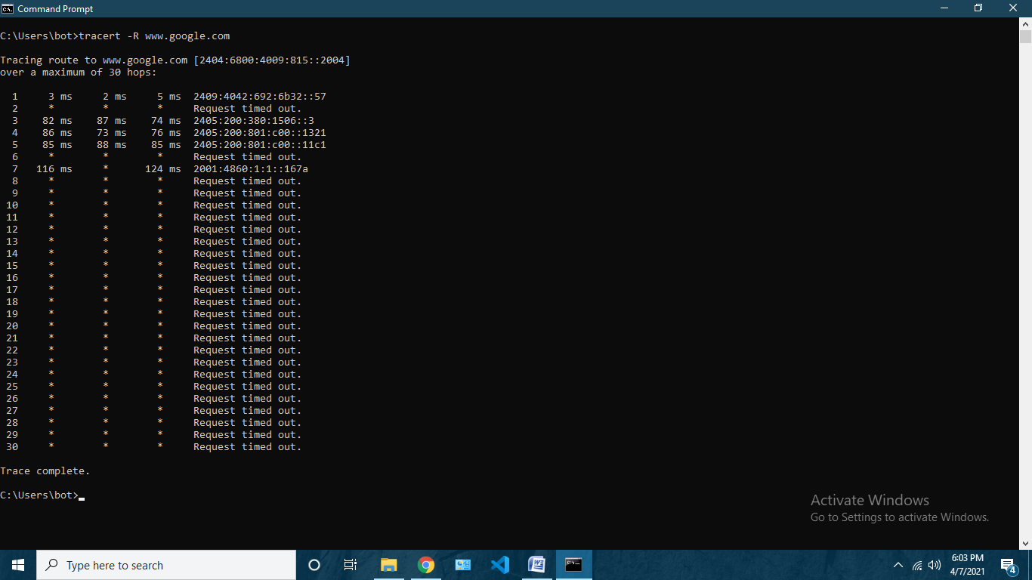
4. ‘option –4‘ is used to force using ipv4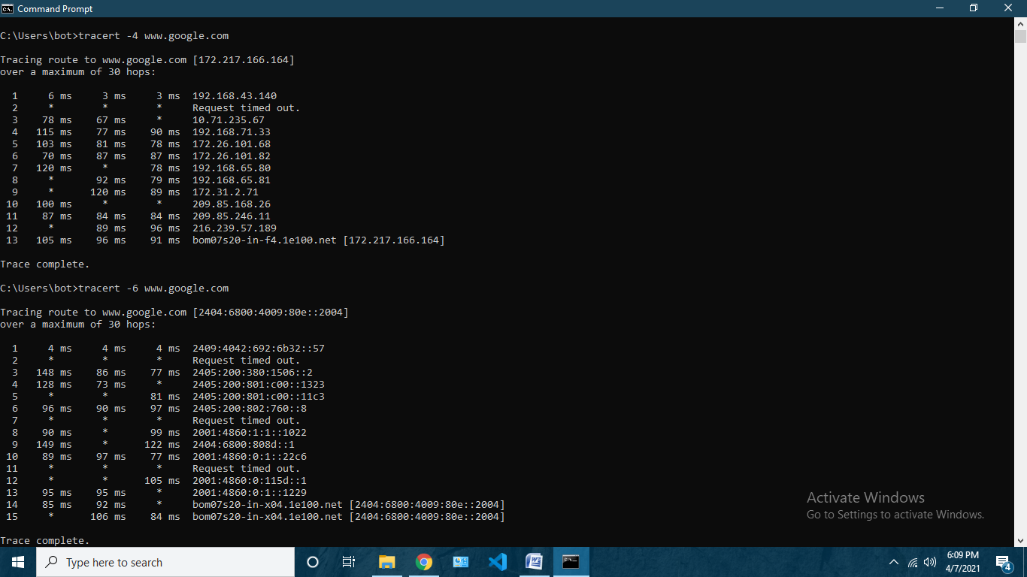
5. ‘option –6’ is used to force using ipv6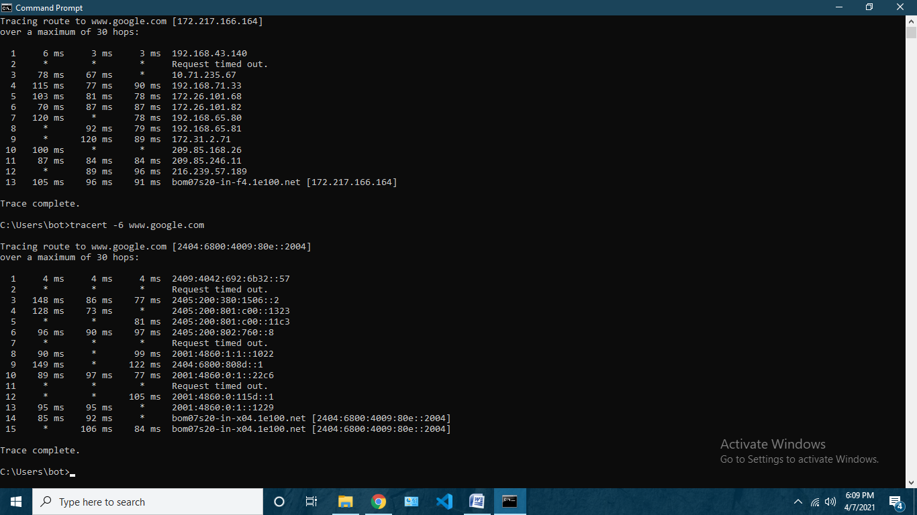

3) Netstat

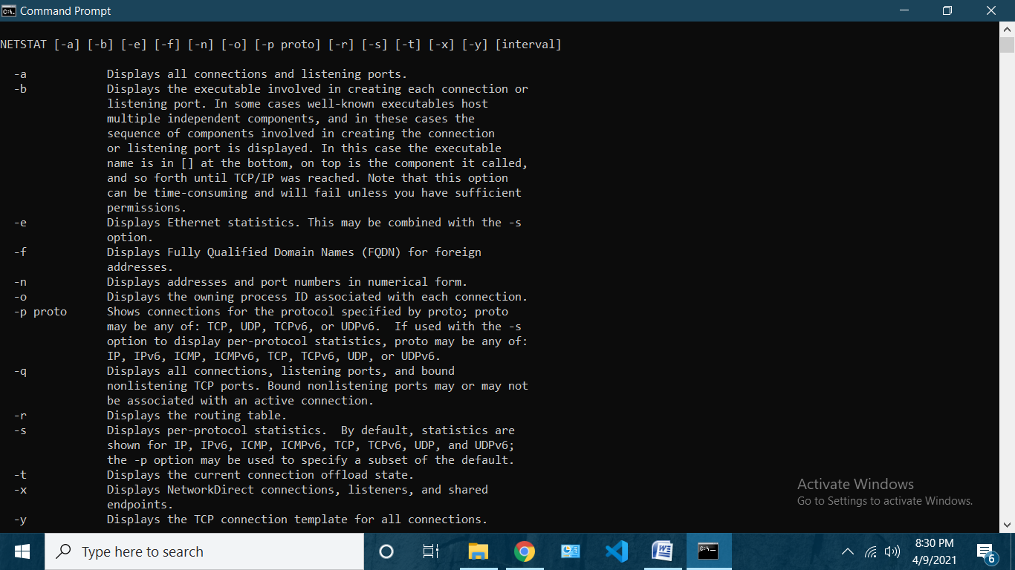

1. “option –a to display all connections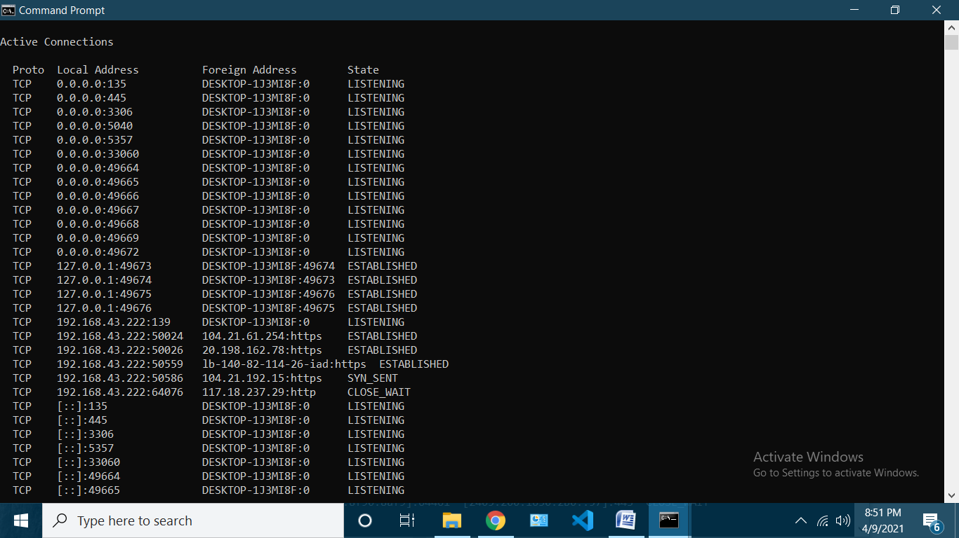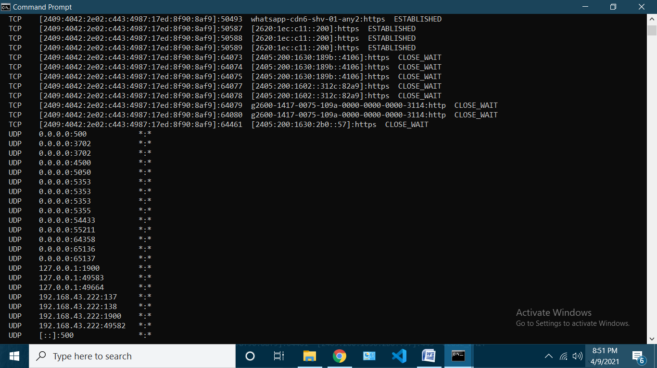
2. “option-n ” displays all port number in numeric form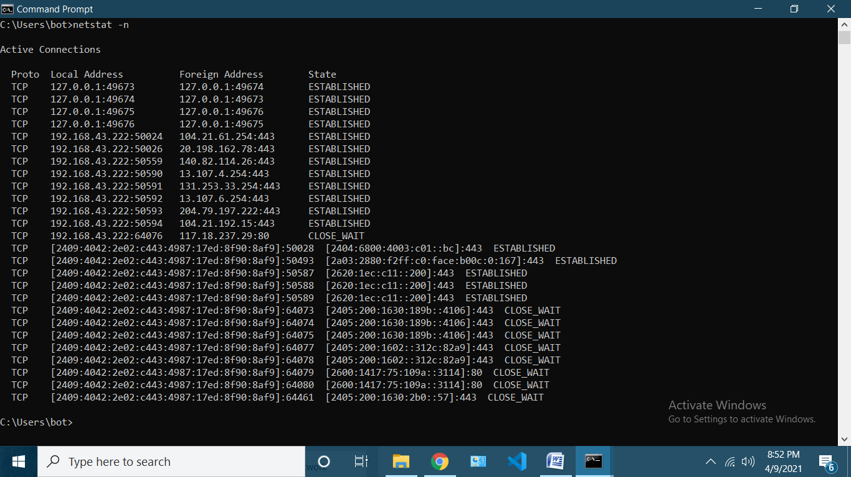
3. “option –r ” displays routing table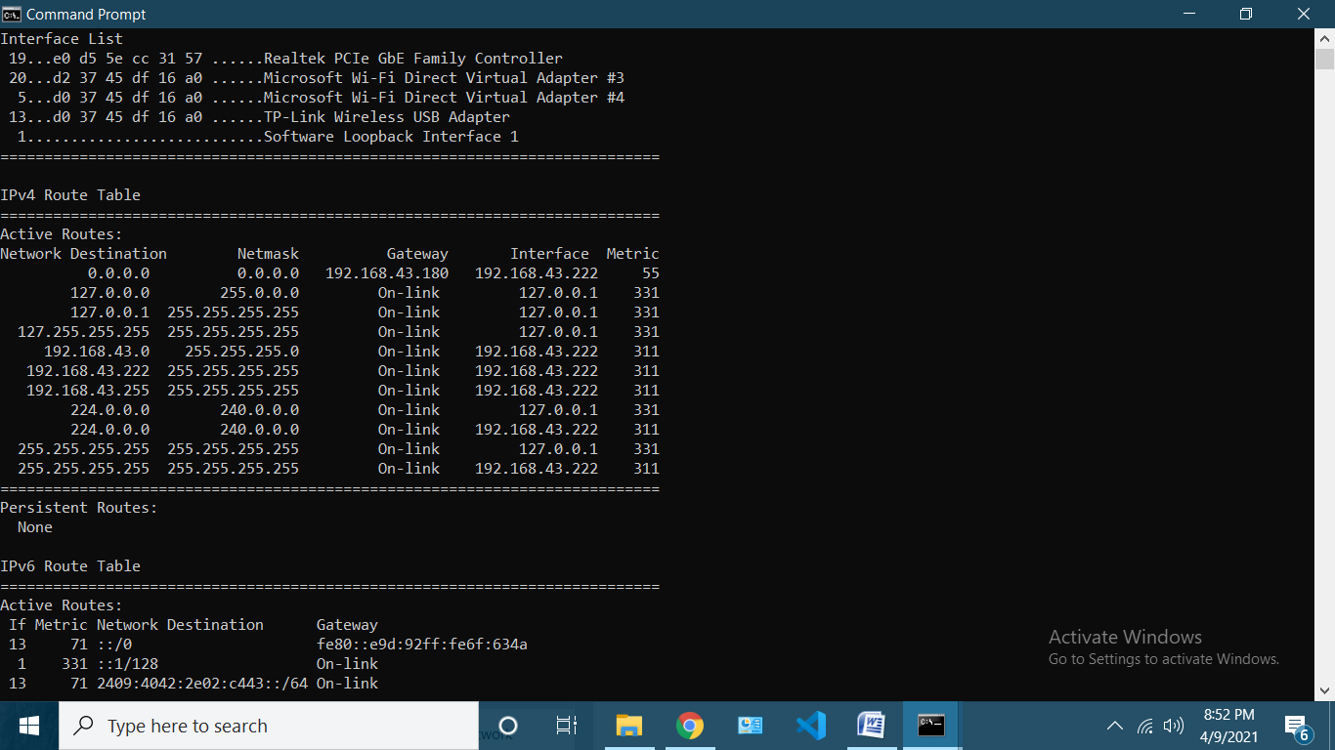
4. “option -s” displays pre protocol statistics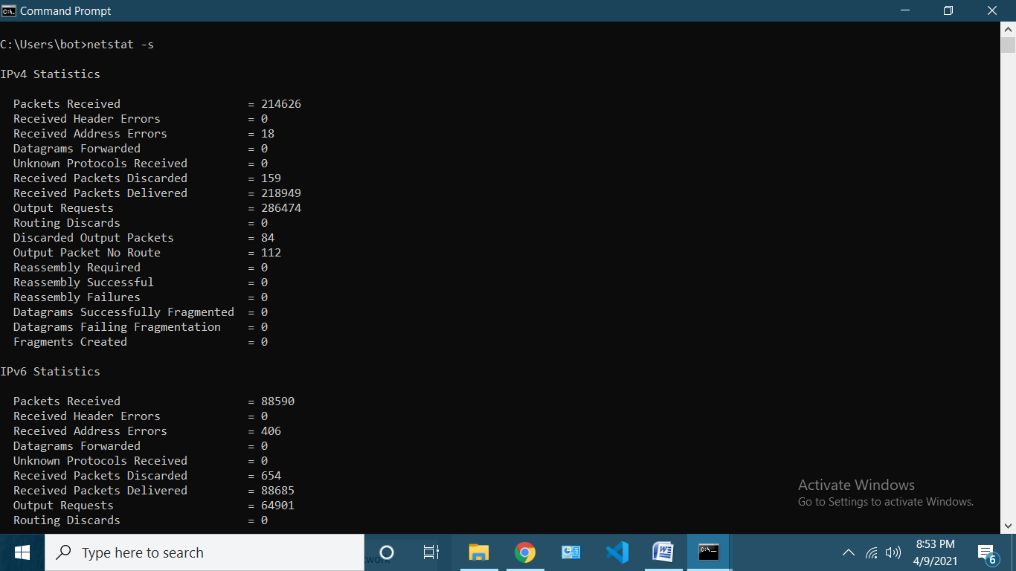
5. “option -y” displays tcp connection template 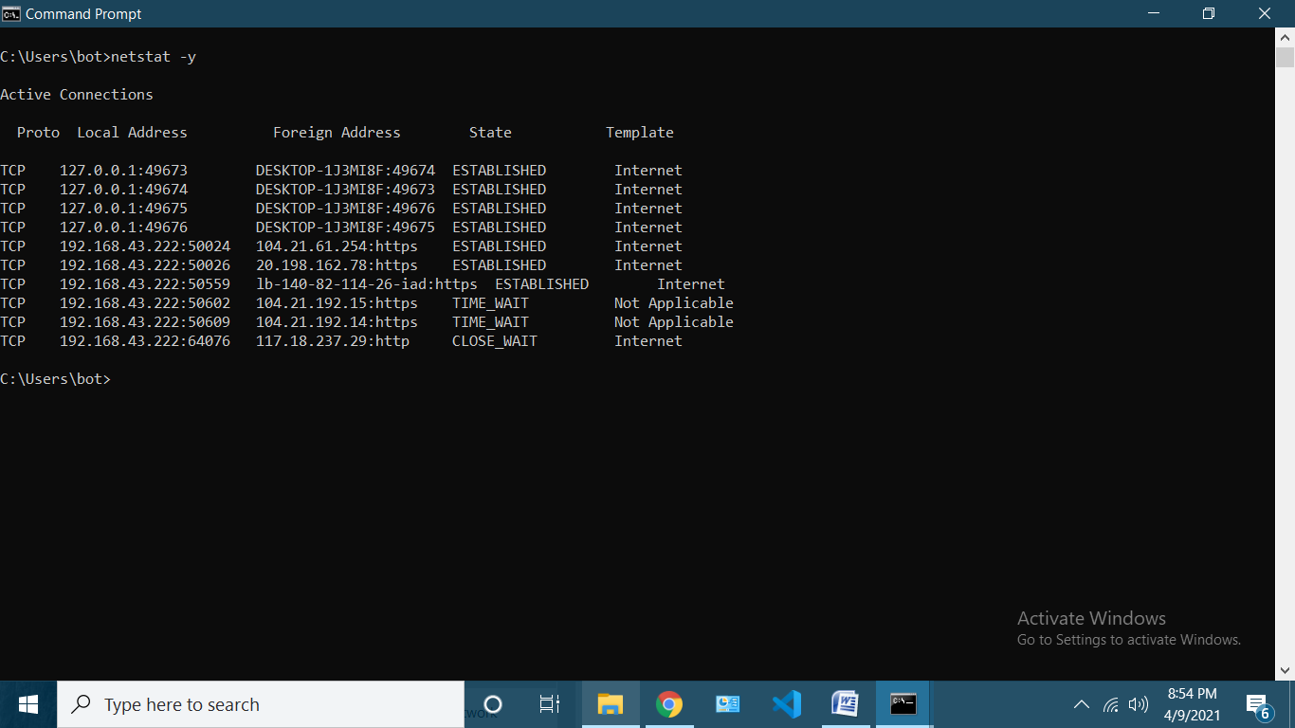

4) arp

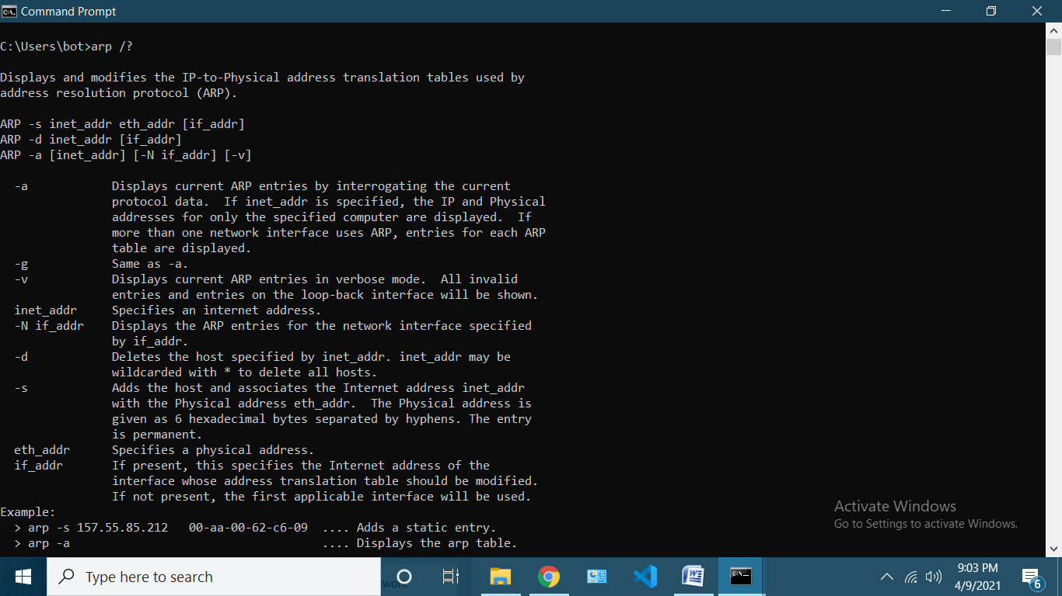

1. ”option –a and –g ”displays arp entriesby interrogating current protocol data 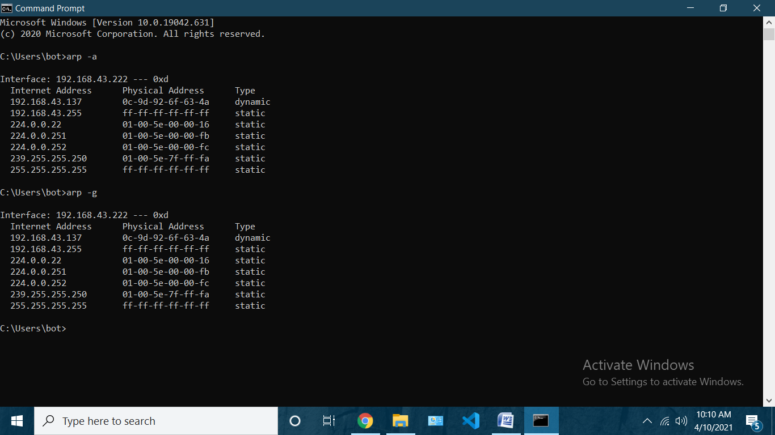
2. “option –v ” displays arp in verbose mode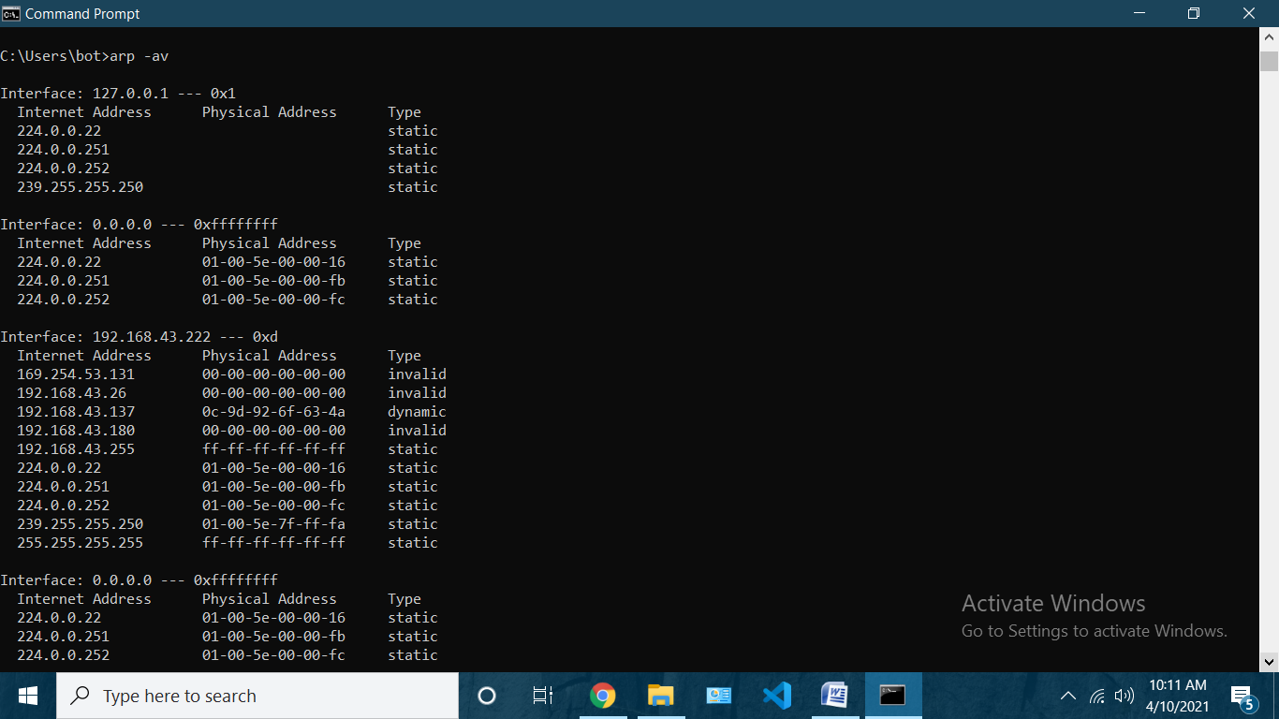
3. “option –d ” is used to delete host specified by inet_addr(requires admin rights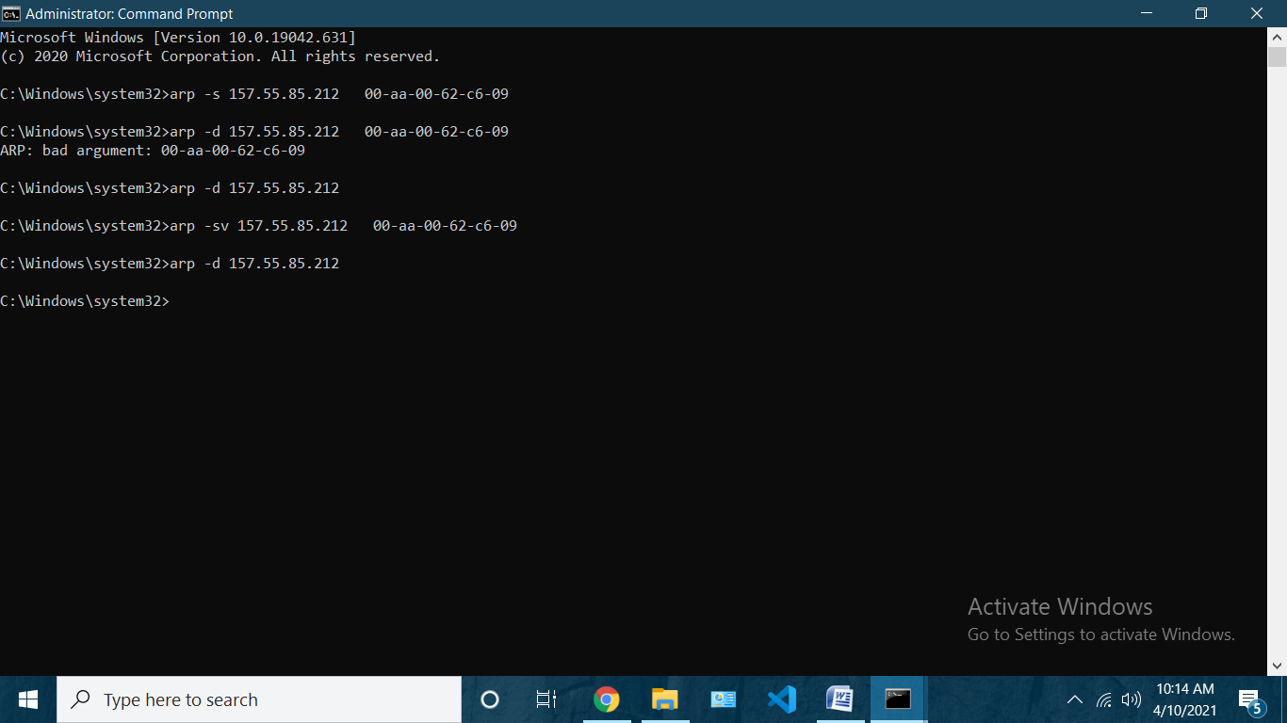)
4. “option -s” is used to add a static entry to the table

5)ipconfig

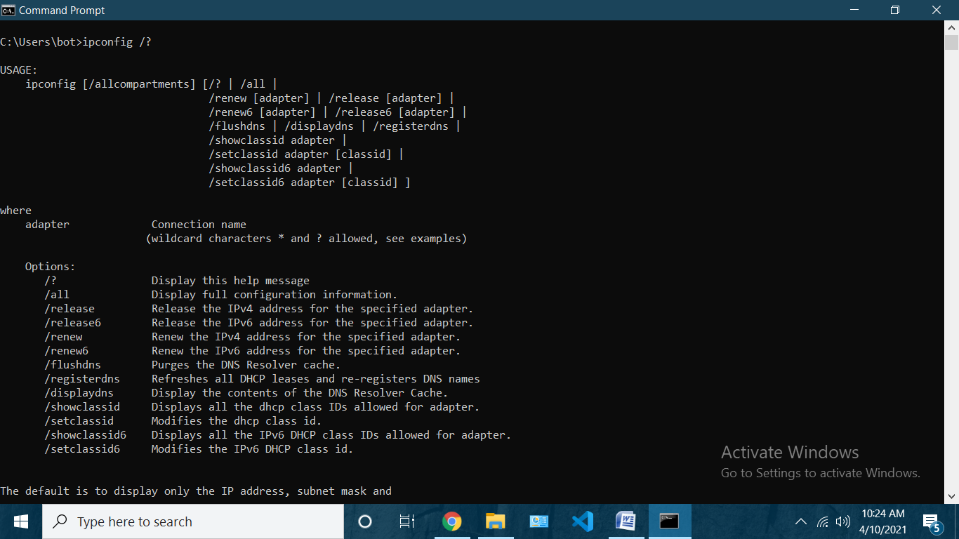

1. “option /all” display full config info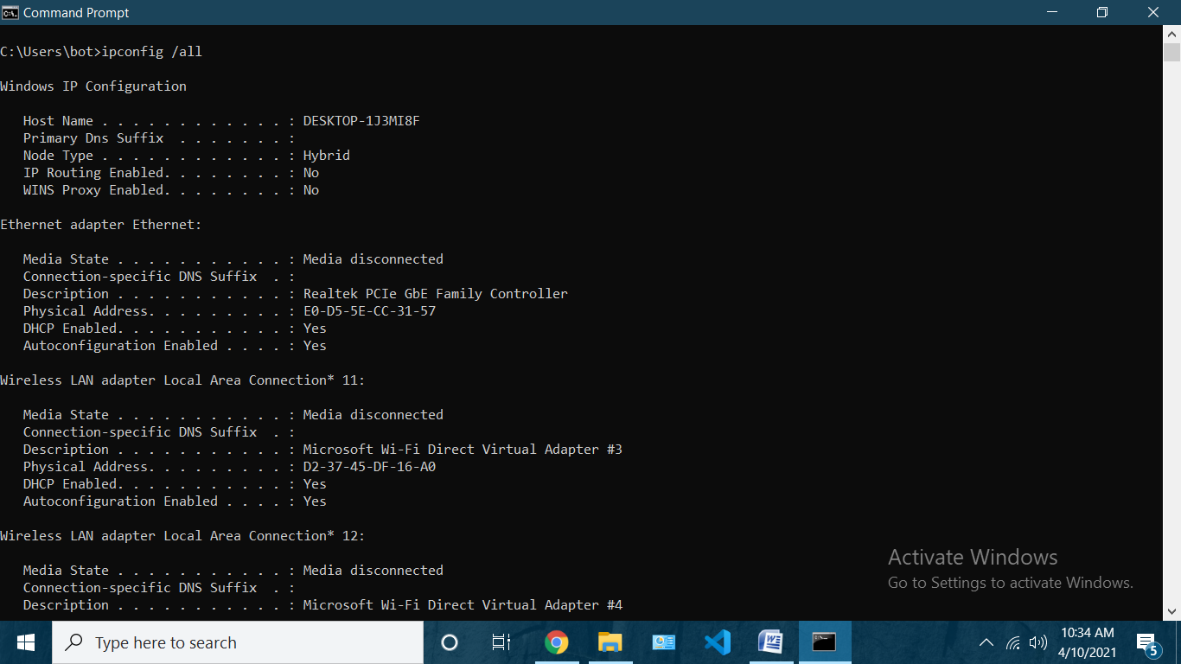
2. “option /release” release the ipv4 address for the specified adapter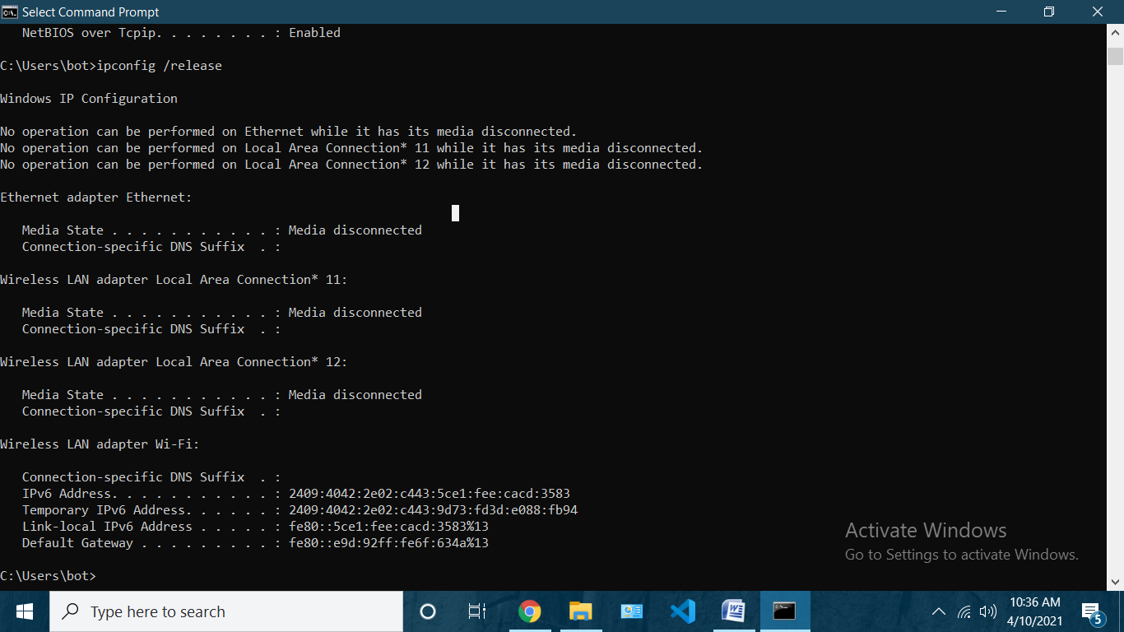
3. “option /release6” release the ipv6 address for the specified adapter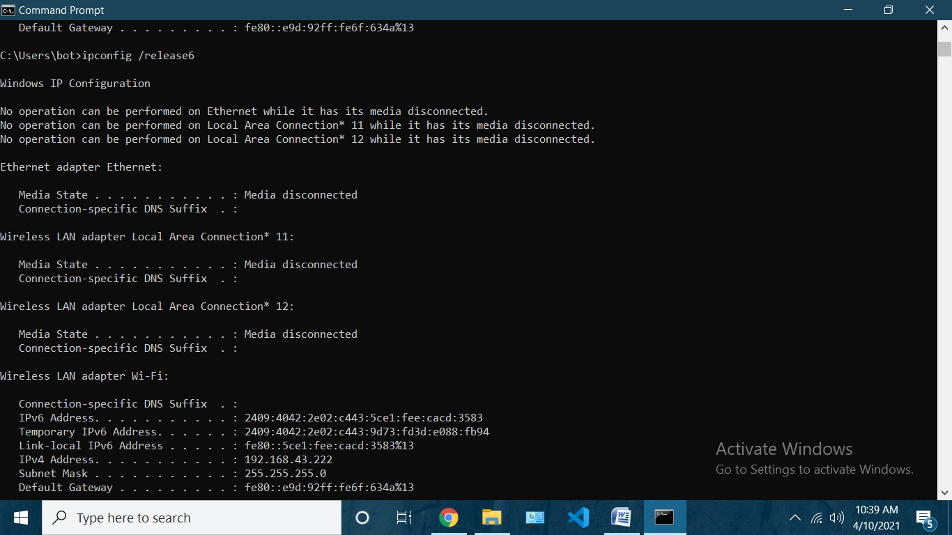
4. “option /renew” Renew the IPv4 address for the specified adapter.

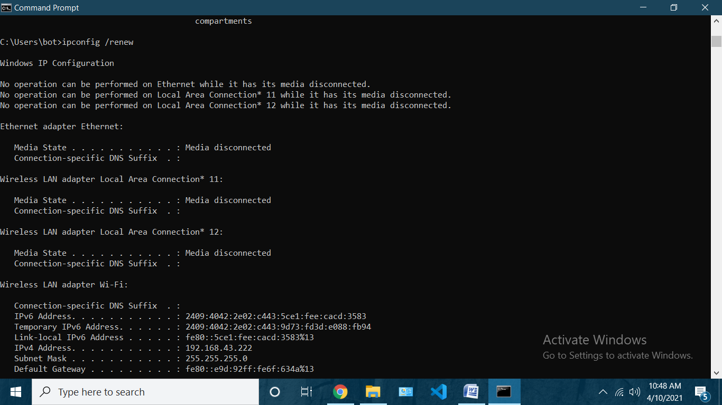

1. “option /renew6 “ Renew the IPv6 address for the specified adapter.

